Smoothing, also called blurring, is an image-processing operation that is frequently used to reduce noise, among other purposes (Gaussian Blur)

Los filtros de afilado se utilizan para resaltar bordes y otros detalles finos dentro de las imágenes. Se basan en derivados de primer y segundo orden. La primera derivada de una imagen calcula una aproximación del gradiente de intensidad de la imagen, mientras que la segunda derivada se define como la divergencia de este gradiente. Dado que el procesamiento de imágenes digitales trata con cantidades discretas (valores de píxeles), las versiones discretas de las derivadas primera y segunda se utilizan para afilar.
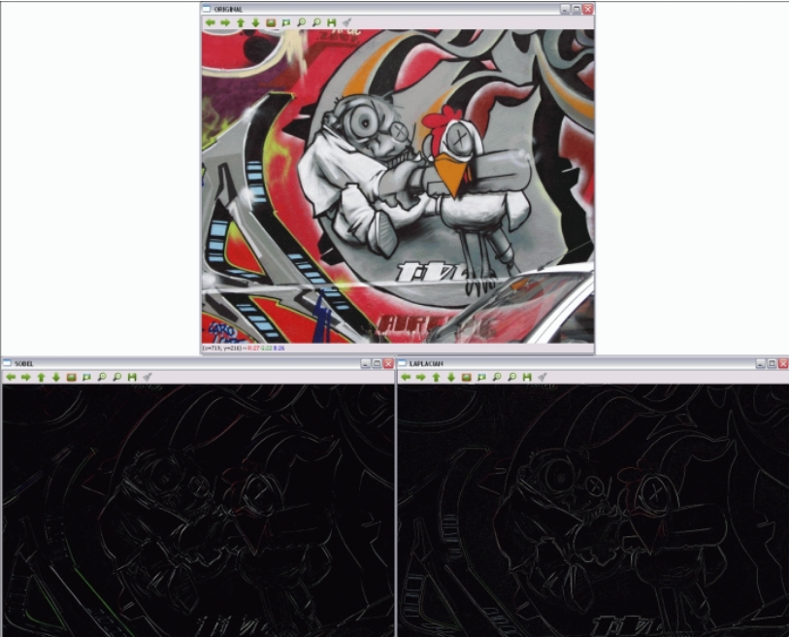
http://proquest.safaribooksonline.com.accedys2.bbtk.ull.es/book/photo-and-graphic-manipulation/9781783287659/firstchapter#X2ludGVybmFsX0h0bWxWaWV3P3htbGlkPTk3ODE3ODMyODc2NTklMkZjaDAzbHZsMnNlYzI1X2h0bWwmcXVlcnk9

OpenCV:
It is interesting to delve a bit into why and how OpenCV was created. OpenCV was officially launched as a research
project within Intel Research to advance technologies in CPU-intensive applications. A lot of the main contributors to
the project included members of Intel Research Russia and Intel's Performance Library Team. The objectives of this
project were listed as:
• Advance vision research by providing not only open but also optimized code for basic vision
infrastructure. (No more reinventing the wheel!)
• Disseminate vision knowledge by providing a common infrastructure that developers could
build on, so that code would be more readily readable and transferable.
• Advance vision-based commercial applications by making portable, performance-optimized
code available for free—with a license that did not require the applications to be open or free
themselves.
The first alpha version of OpenCV was released to the public at the IEEE Conference on Computer Vision and
Pattern Recognition in 2000. Currently, OpenCV is owned by a nonprofit foundation called OpenCV.org.

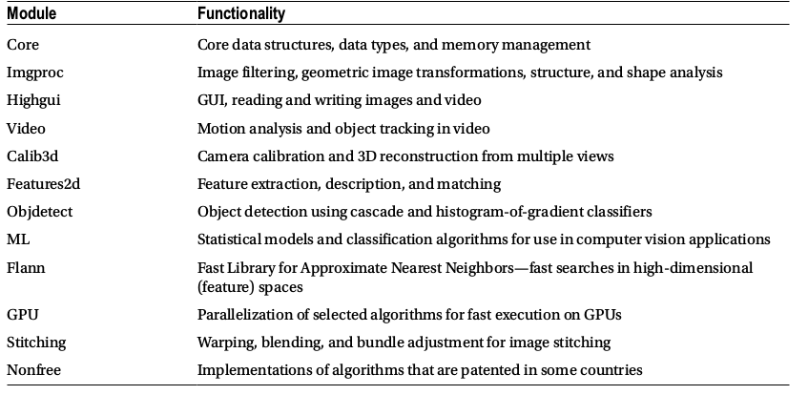

https://github.com/MicrocontrollersAndMore/OpenCV_3_KNN_Character_Recognition_Cpp

